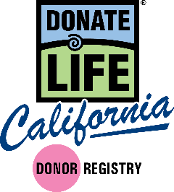
National Donor Sabbath 2016
Copy to use in your congregation’s bulletins, flyers or newsletters

[Religious Organization] supports and encourages organ and tissue donation as the ultimate faith-based gift of one person to another. The Donate Life California Registry helps to save thousands of lives statewide each year. Join the Registry to document your decision to be an organ, eye and tissue donor. For more information about donation or to register, visit donateLIFEcalifornia.org.

[Name of Religion] recognizes the life-saving benefits of organ and tissue donation and encourages all members of our congregation to register as donors on the Donate Life California Registry. The Registry helps to save thousands of lives statewide each year. For more information about donation or to join the Donate Life California Registry to document your decision to be an organ, eye and tissue donor, visit donateLIFEcalifornia.org.

To think of others at a time of grief and sorrow is truly compassionate and selfless. Please register today to give the gift of life through organ, eye and tissue donation. [Name of Religion] supports this gift in the spirit of love and generosity. Join the Donate Life California Registry to document your decision to be an organ, eye and tissue donor. For more information about donation or to register, visit donateLIFEcalifornia.org.

Nearly 120,000 people nationwide — including 22,000 in California — are waiting for life-saving organ transplants, and thousands are in the need of life-enhancing tissue transplants. For many, the chance to live a healthy and productive life won’t come unless all of us consider how we can help give life after death. For more information about donation or to join the Donate Life California Registry to document your decision to be an organ, eye and tissue donor, visit donateLIFEcalifornia.org.

